Alternative pumpkin decorating ideas
Junk drawer pumpkin
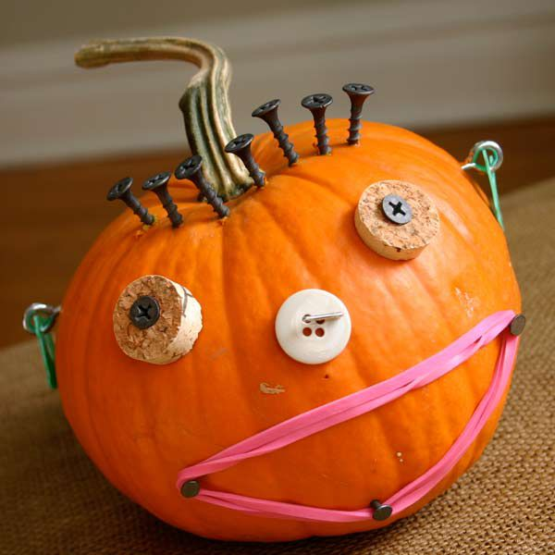

Doily pumpkin
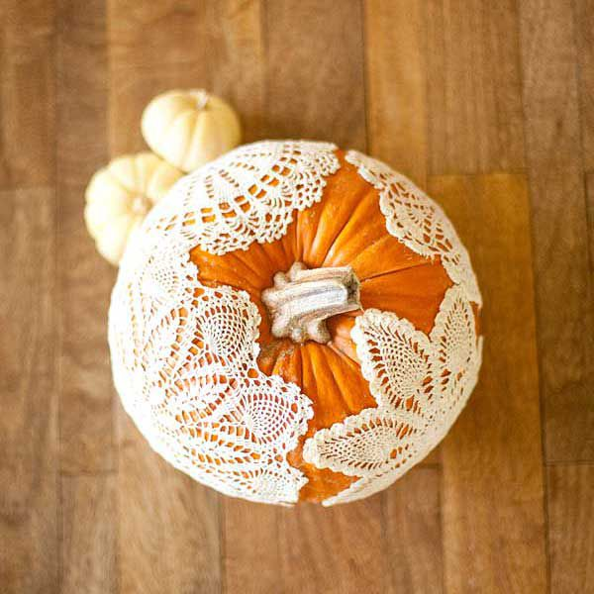

Furniture nails pumpkin (simpy press into the pumpkin in pretty patterns)
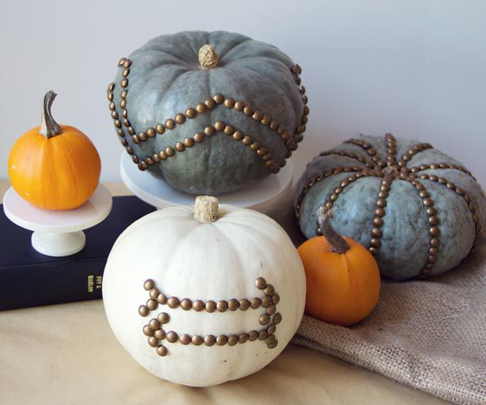
Pumpkin planter (just cut off the top and place your favourite cut flowers in)
